Project Proposal

### Jerry’s e-Rubric System

1. Preface

As the e-class system become more and more popular in Maple Leaf International School, there are more and more e-classroom software are been using in daily class. But, this system is still developing, the function did not covered all of the teaching activities. The main point “rubric” are still be using the paper media for marking the students. And most of the popular e-class system did not have the function of electronic rubric marking. My e-Rubric System are focusing on solving the electronicize of legacy rubric marking process.

In the rest of the proposal, I will introduce this project detailedly in motivations, architectural re & environmental , implementation issues & challenges and deliverables. A time line and a PERT chart will also be included at the end of the proposal.

1. Motivation

As I mentioned before, there are more and more students in the school and the number of students will increasing very fast and for the legacy rubric sheet will take teacher too much time on writing or circling on the physical paper, also teachers must given them back to students . It wasting time and also will make students lost the rubric paper easier when they got too much handouts. For most of the point, teachers will use the e-classroom software to help them manage the mark (e.g. PowerSchool® by Pearson Group). But as many teacher complained to me, most of the e-classroom system do not have a real-time rubric marking application to marking the students assignments or presentations during the class time. They do not have the choices that they only could used the unfriendly paper rubric.

For this e-rubric marking system, it will focusing on solving the rubric efficiency and reliability problems. For this system, teachers could just running the software by double clicking and setting up for 10 seconds. The only process that they need to do is input the students’ information before the start of marking. Also, for helping the teacher to marking, at the upper space of marking process windows, the system will shows out the marking standards table and the balance of the mark. At the end of the marking, the system will storage the marks in a local .xlsx file (Microsoft® Office® Excel Format). It is easy to opening in the Office® Excel program for teachers to reviewing the marks. Students also could getting the e-version of rubric table that they will not lost it any more. This system will also containing some complex marking methods and mark’s calculation methods and more input and output formats in the later evolution of the e-rubric system.

1. Architecture & Environment

In the whole system, the firmware and the main program will be written in Python3. The version required at least Python 3.5.4rc1. The developing and testing environment is Python 3.5.4rc1 on Deepin GNU/Linux 15.5. Also because of the cross-platform feature of Python, this system could running at every platforms, even on the IBM AIX® UNIX operating system.

Because of the GUI library, the client must installed easyGUI® module by pip. Also because of the .xlsx file reading and writing function, the client should installed “xlrd”, ”xlwt” and “openpyxl” modules into the python environment.

1. Implementation Issues & Challenges

As I forecasting, during the whole developing period, there are some difficulty issues that I will meet. The first problem is the design of the GUI graphics. Before this project, I did not learned any knowledge about the design and program the graphic interface. So in the next few weeks, I need to learn more about it and I also need coding the system out in the limited time.

And also, there is the first time that I tried to use the Excel files I/O methods, I do not know that what are the problem that I need to facing to at the later of the time. The testing will cost a lot of time either. It will compress my coding time much further.

For the GUI problem, there have so many solutions that I could use. For example the PyQt solution could make programmer design out a beautiful UI but it is too complicated that I need to learning a brand new language. The default solution Tkinter is easier to calling and building in the program but it is pretty ugly and hard to control the layout, it is also hard to contain the methods. So according to the researching, I found a GUI library called easyGUI®, it is not hard to use and every system level graphical implementations are all finished by the library.

This e-rubric is the first system that specific focusing on rubric marking and it will not bloated as the popular e-classroom, so it is running very fast and crossing all of the platform. It also will have a concise and clear graphical interface for operate. The input and output data will also be based on a graceful experience.

1. Deliverables

At the end of the developing process, I will deliver a mostly bug-free e-Rubric system out also with a helping file. And this system could be distributed to every teacher who need it for the rubric marking.

After the teacher start the program, they could choose is to open the storage folder to review the previous marking or start a new rubric. After they choose to start a new rubric, they could import the standard table and the students table. After that, teacher could start of marking.

For the marking the student, the teacher could choose a specific student to marking or just get a random student. It is very convenient for classing.

1. Time-line

|  |  |  |  |  |  |
| --- | --- | --- | --- | --- | --- |
| Stage | Deliverable/ Date | Description | Estimated Time | Start Date | End Date |
| Starting | June 10th | Start to conception | 1 Day | Day0 | Day0 |
| Learning | June 17th | Learning the extra knowledge | 7 Days | Day1 | Day7 |
| Programming | June 20th | Programming the system | 10 Days | Day1 | Day10 |
| Testing | June 21th | Debugging and Testing the Function | 1 Day | Day10 | Day11 |

PERT CHART

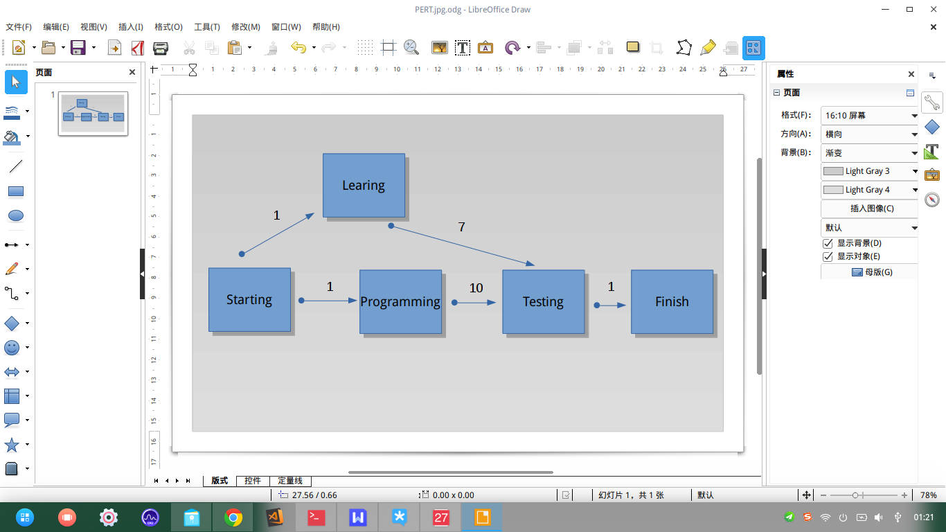

1. Conclusion

In conclusion, the e-Rubric system will increasing the efficiency and reliability of rubric marking activities. It will helping teacher to have a better marking experience. Although the time of development is not very long but also it will become a popular rubric system in teacher’s field.